**Statistical Analysis**

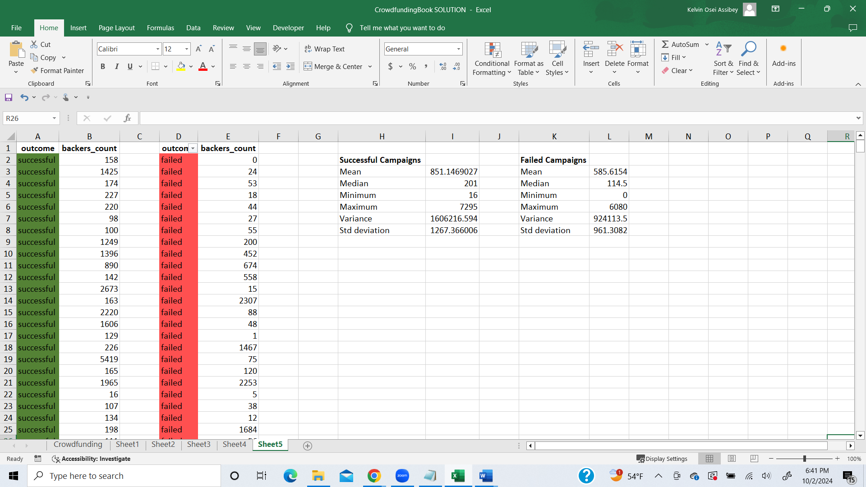

The median best summarizes the data for both successful and failed campaigns. This is because there is a notable difference between the mean and median for both successful and failed campaigns indicating that the data is skewed with outliers.

Theres more variability with the successful campaigns than the unsuccessful campaigns, this is because, successful campaigns have a higher variance (1606216.594) and a higher standard deviation (1267.3660067) compared to the failed campaigns: variance (924113.5) and standard deviation (961.308).

**Yes, it makes sense because of the following reasons:**

* The range between the min (16) and max (7295) of the successful campaigns is higher compared to the failed campaigns. This large range is a key contributor to the higher variability we see with the successful campaign.
* The successful campaigns may include extremely high values (outliers) as it is reflected in the higher variance and standard deviation of the successful campaigns compared to the failed campaigns.

Even though the successful campaigns can be varied widely, failed campaigns have a more stable number backer. These reflect in the low standard deviation (961.3082) of failed campaigns.